Day 4: Social Media Agent (Part-2)

Opening & Recap
Chat Activity:
Write, in one sentence, say what kind of business video do you want your automation to create (e.g., ‘customer welcome’, ‘sales ad’, ‘explainer’, ‘onboarding’).

Quick Theory: JSON – The Universal Data Language

Definition:
JSON (JavaScript Object Notation) is the lightweight, text-based data format nearly all web tools and APIs use for sharing data.
Why do we care?
When you pass data from Google Sheets, OpenAI, HeyGen, or any API, it’s almost always structured as JSON.
How does it work?
- It’s built on “key-value” pairs (just like column and cell in a Google Sheet).
- Curly braces {} surround a single object (one record).
- Square brackets [] surround arrays (lists of objects/records).
- Both objects and arrays can be “nested” inside each other.
Analogy:
Think of a Google Sheet:
- Column header = Key ("name":)
- Cell = Value ("John Doe", 42, true, null, ...)
Example:
json
{
"name": "Amit Kumar",
"role": "Manager",
"skills": ["automation", "AI", "training"]
}

or
json
[
{"name": "Riya", "score": 92},
{"name": "Samir", "score": 95}
]

Real Use:
If HeyGen’s API gives you a link to a finished video, it might look like:
json
{ "video_url": "https://heygen.com/video/xyz", "duration": 56 }

You need to extract the right value to plug into your workflow.
Great beginner video:
- What is JSON? | JSON Tutorial for Beginners

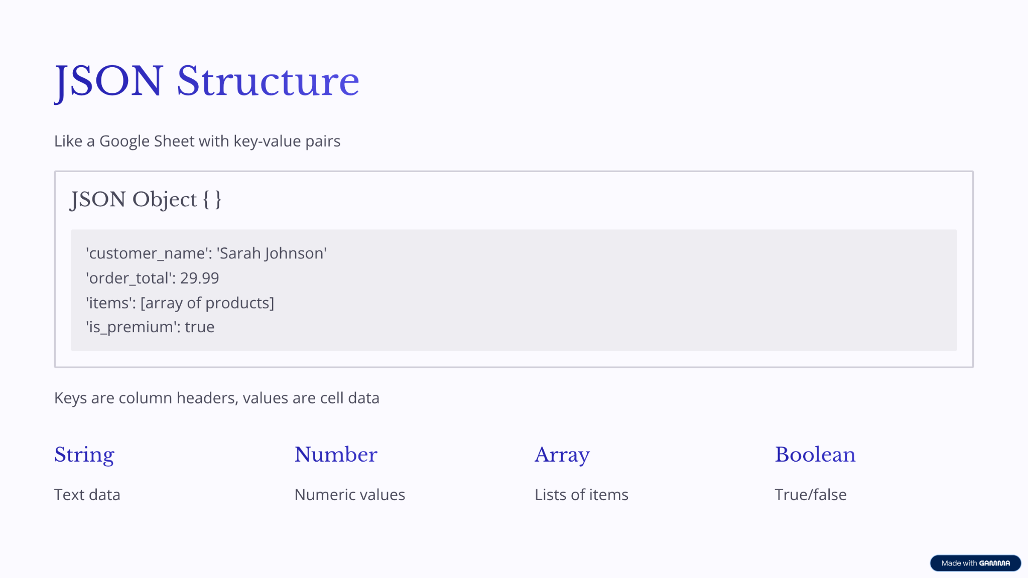

Core Data Types in Workflows
Data must be predictable for the Agent to process it efficiently. These types dictate how data behaves in logic checks:
Data Type | What it Represents | How to Recognize it in Code | Logic Application
String | A sequence of characters; text. | Always wrapped in double quotes: "Hello World". | Reading, generating, or categorizing text outputs.
Number | Numeric values (Integers: whole; Floats: decimals). | No quotes around the value: 42 or 19.99. | Essential for calculations, pricing workflows, and financial reports.
Boolean | A value that is only True or False. | Written as true or false without quotes. | Used heavily in If Nodes for conditional logic (e.g., Is isActive: true?).
Array | An ordered list of values. | Uses square brackets [] around the list. | Helps with looping or bulk processing (e.g., sending 17 customized emails from a list).
Object | A container of key-value pairs. | Uses curly braces {}. | Structured data storage, often representing a full user profile.
Null | Represents data that is missing or doesn't exist. | Comes through as the word null without quotes or an empty string "". | Used to check if a required field was left blank by a user.

Chat Question: Write a Json with your favourite cooking recipe or music with key and value pairs

Instructor Demo: Script to Video Flow
Step 1: Create a System Prompt with the right examples for the Output. Validate the Output

Role: You are an expert at creating UGC Video Content for e-commerce. Context: I work for a brand called Colgate, and I want to create a Social Media Video for 30 sec. Can you ask me questions, and help me think of a concept first?
🎬 Final Minimax Video Prompt — “Confidence Starts in the Mirror”
A 6-second photorealistic UGC video, vertical 9:16, shot on an iPhone front camera inside a small hostel bathroom in urban Bangalore during early morning. Warm sunlight filters through a side window, with light steam and natural imperfections on the mirror. A real Indian teenage boy (17–18 years old) stands in front of the mirror — South Indian origin, medium warm brown skin tone with golden undertones, lean build (~5’8”), soft oval face, dark brown-black hair slightly messy after shower, expressive deep brown eyes, clean-shaven with faint natural stubble, plain white cotton T-shirt. He looks relatable, confident, and genuine — the perfect representation of an urban Bangalore hostel teen, effortlessly cool and self-assured. The handheld shot has natural tremor for realism. [0.0–2.0s] He stands sleepily, then raises his Colgate SlimSoft toothbrush with a faint smirk. Ambient brushing sound and a soft lo-fi morning beat (around 90 BPM) begin playing. [2.0–4.5s] He starts brushing slowly; close-up on the reflection — soft bristles move gently on teeth, water droplets glisten on the mirror. Overlay text appears: “Soft start. Confident day.” [4.5–6.0s] He finishes brushing, wipes his mouth, looks into the mirror with a subtle confident smile, and whispers softly yet clearly: “Confidence? Starts here.” End with a clean smile and the Colgate logo + #ConfidentSmile overlay. Lighting: warm daylight tones with realistic skin highlights. Camera: handheld mirror selfie, shallow depth of field. Audio: gentle brushing SFX mixed with morning ambiance and lo-fi beat. Tone: authentic, fresh, empowering. Keywords: photorealistic, UGC, hostel bathroom, Indian teen, natural lighting, mirror selfie, Colgate SlimSoft toothbrush, urban India, lifestyle confidence, real user, minimal dialogue.
Step 2: Build a System Prompt

Role: You are an expert at creating automation workflows on Zapier.
Context: I am trying to create UGC videos (6 Sec) for my brand colgate
Task: Create System Instructions for my automation workflow in Zapier (Open AI) Conversation Node.
I want to create a system prompt that takes my Input

What kind of video I want to create? (messaging, actors, any other specifications)
Who is my target audience?
Product Image
Video Specifications

Data from these columns

And converts them into something like this

A 6-second photorealistic UGC video, vertical 9:16, shot on an iPhone front camera inside a small hostel bathroom in urban Bangalore during early morning. Warm sunlight filters through a side window, with light steam and natural imperfections on the mirror. A real Indian teenage boy (17–18 years old) stands in front of the mirror — South Indian origin, medium warm brown skin tone with golden undertones, lean build (~5’8”), soft oval face, dark brown-black hair slightly messy after shower, expressive deep brown eyes, clean-shaven with faint natural stubble, plain white cotton T-shirt. He looks relatable, confident, and genuine — the perfect representation of an urban Bangalore hostel teen, effortlessly cool and self-assured. The handheld shot has natural tremor for realism. [0.0–2.0s] He stands sleepily, then raises his Colgate SlimSoft toothbrush with a faint smirk. Ambient brushing sound and a soft lo-fi morning beat (around 90 BPM) begin playing. [2.0–4.5s] He starts brushing slowly; close-up on the reflection — soft bristles move gently on teeth, water droplets glisten on the mirror. Overlay text appears: “Soft start. Confident day.” [4.5–6.0s] He finishes brushing, wipes his mouth, looks into the mirror with a subtle confident smile, and whispers softly yet clearly: “Confidence? Starts here.” End with a clean smile and the Colgate logo + #ConfidentSmile overlay. Lighting: warm daylight tones with realistic skin highlights. Camera: handheld mirror selfie, shallow depth of field. Audio: gentle brushing SFX mixed with morning ambiance and lo-fi beat. Tone: authentic, fresh, empowering. Keywords: photorealistic, UGC, hostel bathroom, Indian teen, natural lighting, mirror selfie, Colgate SlimSoft toothbrush, urban India, lifestyle confidence, real user, minimal dialogue.

It should follow the principles in this script, so convert this into a Video Prompt template for Minimax Image to Video Model.

Output format: Please structure the system prompt as role, context, task, output example with the same script given above as an example and a Video prompt template.

Constraints: Keep it limited to only one scene with 1-2 actors, and 1-2 shots, optimized for 6 sec Instagram viewing. Give the system prompt in text format only, not JSon.

Step 3: Connect it to Fal AI Minimax Video (Image to Video Model) - Use Post
ChatGPT Prompt:
Hi ChatGPT. I am trying to create this workflow on Zapier that takes my Input from an google sheet. In the google sheet, I have this data: 1. What kind of video I want to create? (messaging, actors, any other specifications) 2. Product Image 3.Video Script 4. Video Specifications. Now I want you tell me how can I create a video using this input from Minimax via Fal.AI. I want to use Minimax Image to Video Model for creating my videos. Please guide me step by step on how should I send a request to Fal AI Minimax, and How I can get my video.

Prompt 2:

These are my sections in Zapier webhook node.
Data
﻿
﻿
Add value set
Unflatten
Yes
No
Basic Auth
﻿
Headers
﻿
﻿Add value set Can you help me understand how to fill this - the end point URL for minimax Video, the JSON headers in the exact format given in Zapier, and as per my Input, and Authorization details.

Step 3:

Wrap-Up & Key Takeaways
- JSON glues all this data together, knowing how to spot and use it makes multi app/steps automation possible!
- You’ve now built end-to-end script to video content automation.
- Final Reflection: “What’s one part of business communication you’d like to automate as video next?”

Review Your New Superpowers:

- :AI UGC video creation with professional quality
- Advanced OpenAI prompting: Context-aware script generation
- Google Drive integration: Organized file management
- Multi-step Zapier workflows: Complex automation orchestration
- Form to video pipeline: Complete content creation automation

The Business Impact You've Achieved:
- Reduced video production cost from $500-5000 to $5-15 per video
- Cut production time from days to minutes
- Created scalable system for unlimited content creation
- Built professional-quality output without technical expertise

Chat Reflection: "Complete this sentence: 'The most valuable video content I can now create automatically is...'"

The Journey So Far:
- Day 1: Understanding AI agents and automation foundations ✓
- Day 2: Prompt engineering + basic automation setup ✓
- Day 3: HTTP requests + AI API integration ✓
- Day 4: AI avatar video content creation ✓
- Day 5: Reflection on what we learnt so far.

